In-class Assignment 2

Instructor: Qasim Ali

# **Develop and Deploy a Machine Learning Application using Docker**

**Group C**

**Govind Ram Gupta Belde**

**Assignment Steps**

**Step 1: Set Up the VM**

1. **Update the System**

1. **Install Necessary Packages**
   * Install curl and git:

sudo apt install -y curl git

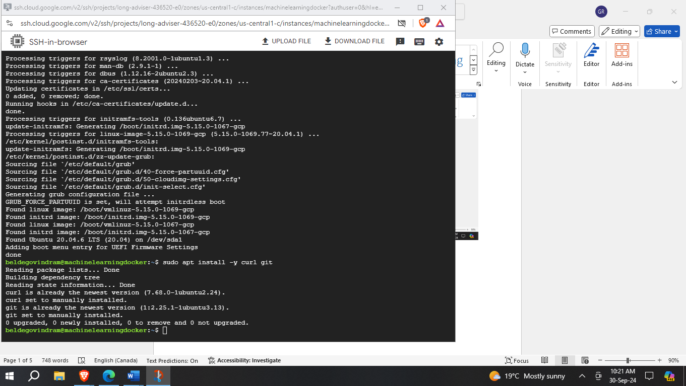

**Step 2: Install Docker**

1. **Remove Old Versions**
   * Remove any old versions of Docker if present:

There are no versions of docker installed so we proceed.

1. **Set Up the Docker Repository**
   * Run the following commands to set up the Docker repository:

sudo apt update

sudo apt install -y apt-transport-https ca-certificates

curl gnupg lsb-release curl -fsSL https://download.docker.com/linux/ubuntu/gpg | sudo gpg --dearmor -o /usr/share/keyrings/docker-archive-keyring.gpg

echo "deb [arch=$(dpkg --print-architecture) signed-by=/usr/share/keyrings/docker-archive-keyring.gpg] https://download.docker.com/linux/ubuntu $(lsb_release -cs) stable" | sudo tee /etc/apt/sources.list.d/docker.list > /dev/null

1. **Install Docker Engine**
   * Install Docker Engine using the following command:

sudo apt update sudo apt install -y docker-ce docker-ce-cli containerd.io

1. **Verify Docker Installation**
   * Verify that Docker is installed correctly by running:

sudo docker run hello-world

WE can see that docker is installed correctly.

**Step 3: Create a Dockerfile for the ML Application**

1. **Create Project Directory**
   * Create a directory for your project and navigate into it:

mkdir ml-app cd ml-app

1. **Create a Dockerfile**
   * Create a **Dockerfile** with the following content:

# Use an official Python runtime as a parent image

FROM python:3.9-slim

# Set the working directory

WORKDIR /usr/src/app

# Copy the current directory contents into the container at /usr/src/app

*****YOU NEED TO WRITE COMMAND HERE*****

# Install any needed packages specified in requirements.txt RUN pip install --no-cache-dir -r requirements.txt # Make port 80 available to the world outside this container EXPOSE 80

# Run app.py when the container launches CMD ["python", "app.py"]

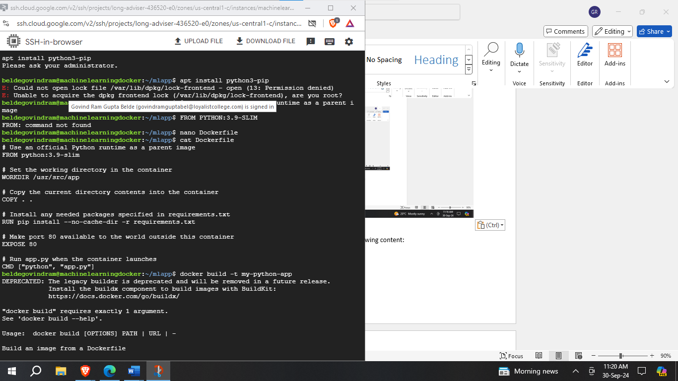

1. **Create requirements.txt File**
   * Create a **requirements.txt** file with the following content:

Flask

Numpy

Pandas

scikit-learn

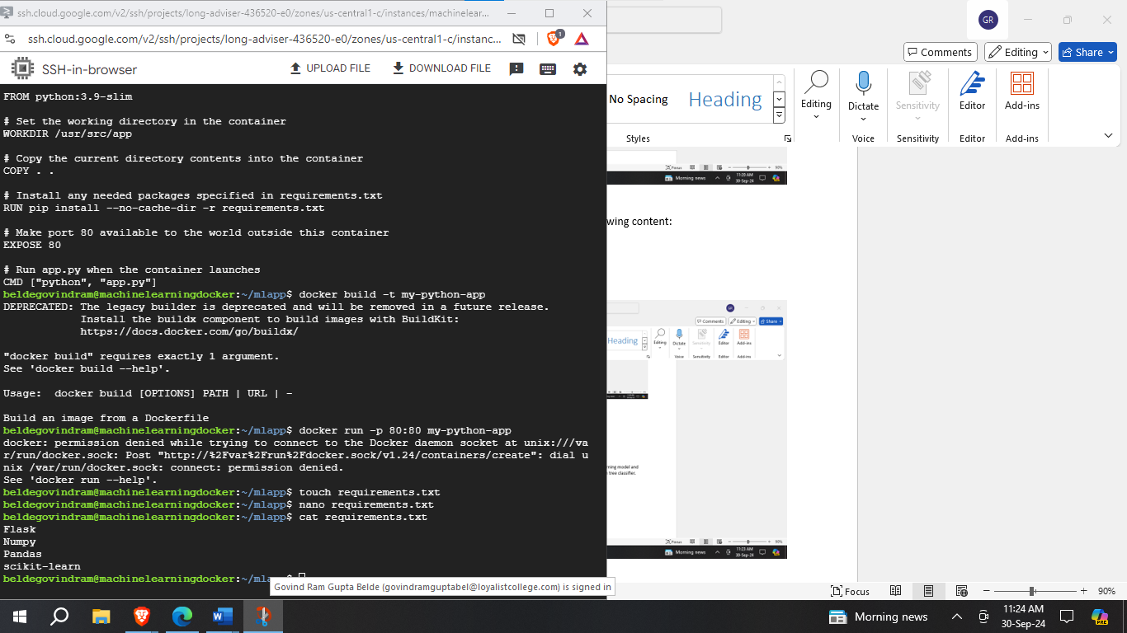

**Step 4: Develop the Machine Learning Application**

1. **Create a Simple ML Model**
   * Create a script **train_model.py** to train a simple machine learning model and save it. For simplicity, we'll use the Iris dataset and a decision tree classifier.

from sklearn.datasets import load_iris

from sklearn.tree import DecisionTreeClassifier

import pickle

# Load the Iris dataset

iris = load_iris()

X, y = iris.data, iris.target

# Train a decision tree classifier

clf = DecisionTreeClassifier() clf.fit(X, y)

# Save the model to a file

with open('model.pkl', 'wb') as f:

pickle.dump(clf, f)

1. **Run the Model Training Script**
   * Run the **train_model.py** script to generate **model.pkl**:

python train_model.py

Sccessfully trained the model

1. **Integrate the Model into the Flask App**
   * Update **app.py** to load the trained model and use it for predictions:

from flask import Flask, request, jsonify

import pickle

import numpy as np

app = Flask(__name__)

# Load the trained model

with open('model.pkl', 'rb') as f:

model = pickle.load(f)

@app.route('/')

def hello_world():

return 'Hello, Docker!'

@app.route('/predict', methods=['POST'])

def predict():

data = request.get_json(force=True)

prediction = model.predict(np.array(data['input']).reshape(1, -1))

return jsonify({'prediction': int(prediction[0])})

if __name__ == '__main__':

app.run(host='0.0.0.0', port=80)

1. **Update the Project Directory**
   * Ensure your project directory contains the following files:
     + **Dockerfile**
     + **requirements.txt**
     + **train_model.py**
     + **app.py**
     + **model.pkl** (generated after running **train_model.py**)

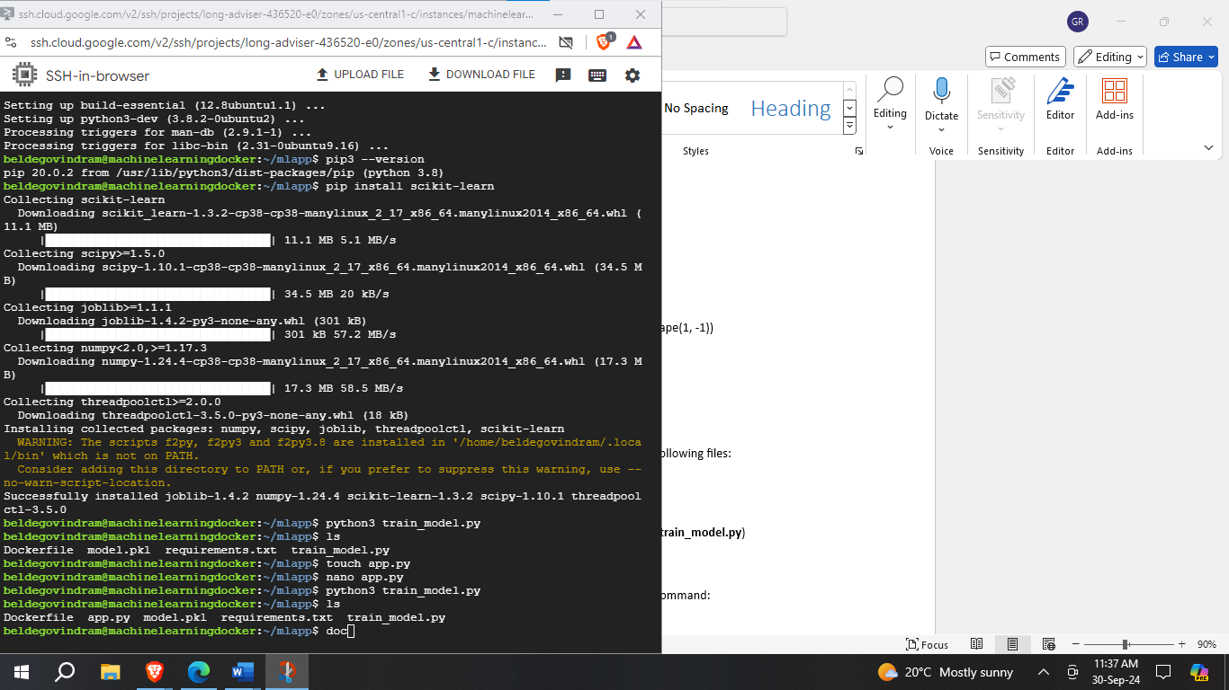

**Step 5: Build and Run the Docker Container**

1. **Build the Docker Image**
   * Build the Docker image with the following command:

sudo docker build -t ml-app .

1. **Run the Docker Container**
   * Run the Docker container with the following command:

sudo docker run -p 4000:80 ml-app

1. **Access the Application**
   * Open your browser and navigate to **http://localhost:4000** to see the running application.

1. **Test the ML Endpoint**
   * Test the **/predict** endpoint using **curl** or Postman by sending a POST request with JSON data:

curl -X POST http://localhost:4000/predict -H "Content-Type: application/json" -d '{"input": [5.1, 3.5, 1.4, 0.2]}'

**Step 6: Deploy the Application to GitHub**

1. **Initialize a Git Repository**
   * Initialize a Git repository in your project directory:

git init

1. **Add All Files and Commit**
   * Add all files to the repository and commit:

git add .

git commit -m "Initial commit"

1. **Create a New Repository on GitHub**
   * Create a new repository on GitHub and follow the instructions to push your local repository to GitHub:

git remote add origin https://github.com/yourusername/your-repository.git

git branch -M main

git push -u origin main

**Step 7: Document the Process**

1. **Create a README.md File**
   * Document the process in a **README.md** file in your repository. Include the following:
     + Overview of the project
     + Instructions to build and run the Docker container
     + Instructions to test the ML endpoint
     + Any other relevant information about the project

**Submission**

* Take screenshots of every step you perform and paste in the submission word/pdf file.
* Submit the GitHub repository link of your project.
* Ensure your repository is public and the README.md file is well-documented.